LACCD Student E-Mail Getting Started Guide
Outlook Live: Understanding your Inbox and Composing Emails
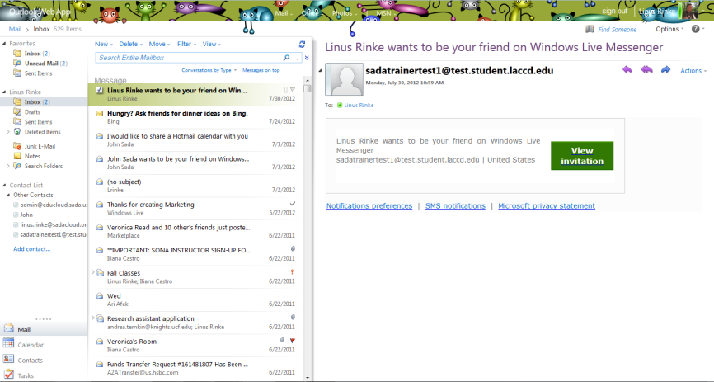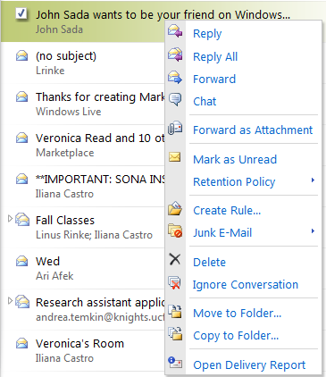The Outlook Live Web Application included in the Live@edu suite is very similar to the Desktop version of Outlook you may already be familiar with some additional productivity features. The inbox is organized in the traditional three pane view with folders on the left, emails in the middle and the reading pane on the right. Since the familiar toolbar ribbon is absent in the online version of Outlook most actions can be completed by right clicking on an email. Above the middle pane users can also search for emails, compose a new message, delete emails or change the view of their inbox. One new addition in the Outlook Web App is something called Conversation View which groups all emails of a similar subject into one thread, eliminating the need to switch back and forth between different folders to find an email!
The traditional three pane view is still evident in the Outlook Web App
All actions in the Outlook Web Application can be complete by right clicking

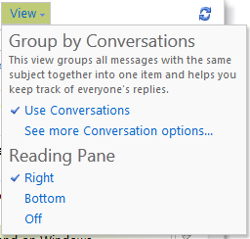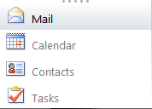
Students can compose a new message, delete emails, move emails to a folder or change the organizational view of their inbox using the toolbar above the middle pane
Conversation view is a new addition in Outlook Web App. Students can disable this feature by clicking on the view button above their inbox
Users can switch back and forth between their different applications directly from within the Outlook Web App

Outlook Calendar: Sharing and Creating Calendars
Included in the Live@edu suite is the Outlook Calendar Application that allows students to keep their busy lives organized and share out their calendars with other students. Every student’s calendar by default will be set to private and each user can decide who they do and do not want to share their calendar with. They can also create secondary calendars to keep track of every facet of their lives from Classes to Sports Events and everything in between. Much like with the Desktop version of Outlook students can also use tools like the scheduling assistant to quickly and easily identify times they can meet with their peers.
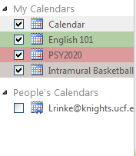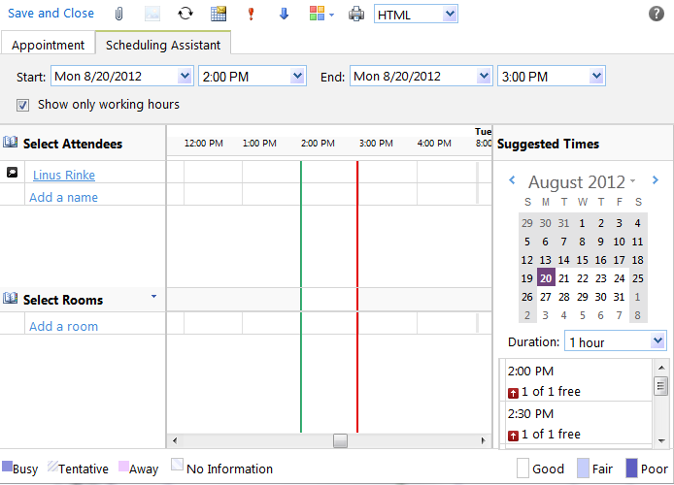

Students can create secondary calendars using the left click function to keep every part of their lives organized
The scheduling assistant tool can be utilized by students to schedule meetings with their peers. This tool is available from the create meeting window

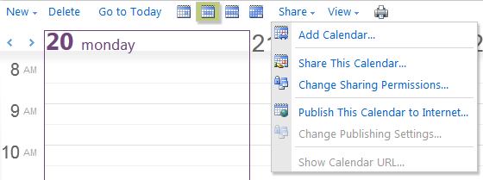

Above their calendar application students can create new Meetings or Appointments, change their calendar view, create a new calendar or even share their calendar out.

Live@edu SkyDrive: Uploading Files, Creating and Sharing Documents
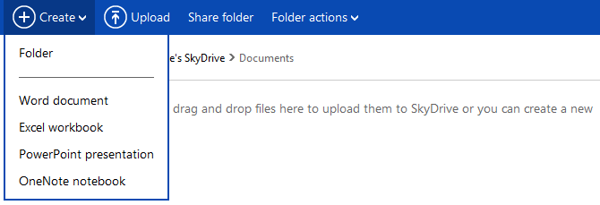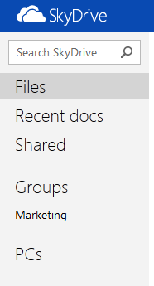Microsoft SkyDrive is an online storage application that allows students to upload images, videos, documents and virtually any other files they would like to have access to on the go. The days of emailing yourself an attachment or carrying around a flash drive are over since all files can be accessed wherever a student can log in to their account. They can also create Microsoft Office documents right from their web browser and even share and work on those documents with other students in real time. With more and more products being integrated into the cloud SkyDrive will keep students one step ahead with cloud storage.
Students can create Word, OneNote, PowerPoint and Excel documents right from within their sky drive application. They can even upload existing documents from their desktop and access those files from anywhere they can log in to their accounts

Students have access to their own files, as well as all files others have shared with them. They even have the option of creating Collaborative Groups to seamlessly share documents or files with groups of students

Frequently Asked Questions
- What is Live@edu?
  - Microsoft Live@edu is a no-cost e-mail and collaboration services, co-branded for schools. Live@edu is a platform that supports the collaborative campus of the 21st century. Outlook Live e-mail service provides the familiar and reliable Outlook Web Access (OWA) co-branded with your school’s name and logo for students and alumni. And it’s more than just e-mail. Live@edu includes access to other programs and services that increase your school’s ability to collaborate and communicate, including calendars, document sharing, shared workspaces, blogs, instant messaging, video chat, mobile e-mail and document access, and address books.
- How much storage do I get in an Outlook Live Mail account?
  - Every Outlook Live Account features 10gb’s of Storage meaning students no longer have to delete emails to save space. Additionally, every account will also receive another 25gb’s of storage to use in a free online file storage program called SkyDrive.
- What are the differences between this and the Outlook application I already know how to use?
  - Most of features that you are already familiar with are available in the Outlook Live Web Application. A few minor differences include: No ability to archive emails, access to your emails from every web browser, and a built in messenger application to speak with other students in real time.
- Will this be the primary means of communication for all students in LACCD?
  - Yes, every student will be provisioned an email account when they submit an application and this will be the official means of communication for all students once the rollout is complete
- How does the public Calendar application work?
  - Students have the ability to share their personal or secondary calendars with other students and have access to tools like the scheduling assistant to easily and quickly set up meetings with other students
- What is SkyDrive?
  - SkyDrive is a free online storage file system that allows students to upload files and create basic Microsoft Office Documents. The days of carrying around a flash drive or emailing yourself an attachment are now over since all files can be accessed from any online portal
- How much storage do I get in a SkyDrive account
  - Every student will receive 25gb’s of storage in their SkyDrive application
- What applications can I work with within SkyDrive
  - Students have the option of creating Word, PowerPoint, Excel and OneNote documents right from within their SkyDrive portal. They can also seamlessly switch between working in the cloud or on their desktop application. With more work being accomplished through teams and groups breaking down the traditional classroom wall is becoming critical
- Is SkyDrive available for any mobile devices?
  - Yes, the SkyDrive application can be accessed from most smartphones including: Windows Phone, iPhone and Android devices
- Why are there so many different kinds of groups users can create in the Live@edu suite?
  - There are three kinds of groups a user can create in the Live@edu suite: Private groups from within the contacts page, public groups from within the settings page and collaborative groups from within the SkyDrive application.

