FREQUENTLY ASKED QUESTIONS
- How do I logon to email?
  - Method 1:
    - Login in to your student email account at https://student.laccd.edu/sso/ Enter your LACCD student ID number here
    - Your Password is the same password for your student information system.

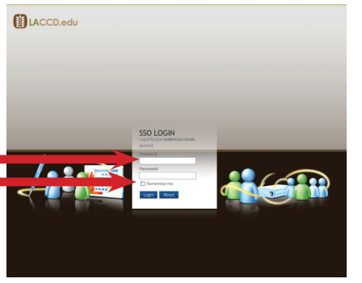

  - Method 2
    - Login to your student portal
    - Click on the link that email address next to “Assigned Student E-Mail Address”
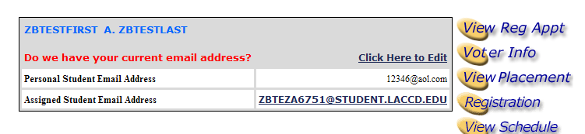
    - You will be redirected to your email inbox.

- What do I do if I do not remember my password?
  - If you do not remember your password you need to contact your Admissions and Records Office. They will assist you in obtaining your student pin.

- Where do I go if I want to change my pin?
  - To change your pin you can use the student information system portal.
  - Go to the student portal where you access your registration and grading information. You can access this from the college sites or from the district site.
  - Log in to the portal
  - Click on “Change Pin” on the left navigation menu

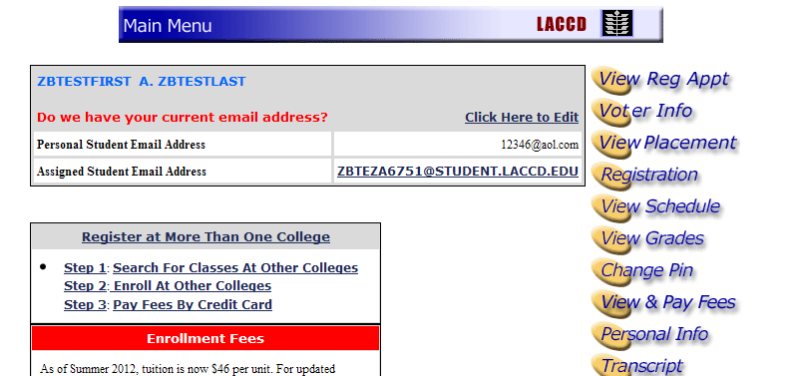

  - Create a new pin and submit
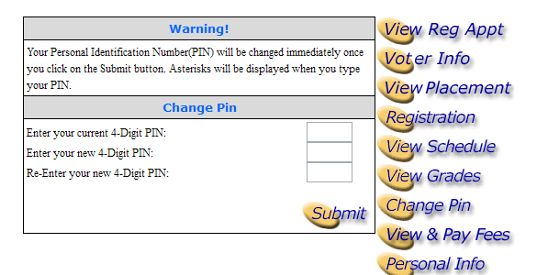
  - Once the password has change it will be updated for your email account to.
- Who do I contact if I do not have an email address?
  - Contact your campus Admissions and Records office. They can assist you in identifying your email address
- How do I get information on how to use the email system?
  - Visit www.outlook.com to get help and reference information regarding the different options
- What is SkyDrive?
  - SkyDrive is the cloud based collaboration center where you upload and store files, use Microsoft office products such as Microsoft Word, Excel and Powerpoint
- Where can I get help information about SkyDrive?
  - Visit http://windows.microsoft.com/en-US/skydrive/help-center to get various different information regarding SkyDrive and its capabilities.
- How much storage space do I get for email?
  - You will get 10GB of storage for your email.
- How much space do I get on SkyDrive?
  - You will get 25GB of storage space in the cloud.
- Does the space on SkyDrive include the storage space for my email?
  - Your email storage space is separate from your SkyDrive storage space. This space can be used for uploading and creating new files using the SkyDrive options.
- What happens if I reach my storage space limit of 10GB?
  - If you reach the maximum limit of 10GB for your email, you will not be able to receive any more emails until the mailbox is cleaned up.

